 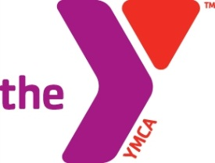

**YMCA of South Florida L.E.A.P High**

**Program Eligibility Form**

The YMCA of South Florida is pleased to offer in-school and out-of-school programs that will help your child transition from middle school to high school, minimize or avoid delinquent behaviors, and develop clear plans for academic success in high school and after graduating. The Literacy Enrichment Academic Pursuit High (L.E.A.P High) Program aims to create a community of support for students and families by placing two full-time Success Coaches at each of various schools within Broward County. The Success Coach will work with students who have been accepted into the LEAP HIGH program. This program will require the completion of this eligibility form as well as a YMCA registration form and an intake package. Students who enroll in this program must be actively participating in the YMCA’s afterschool and / or summer programs, throughout the year.

**Students who qualify encounter one or more of the following:**

|  |  |  |  |  |  |  |  |  |
| --- | --- | --- | --- | --- | --- | --- | --- | --- |
| **Must in 9th or 10th grade** |  | *Reading below grade level* |  | *In need of credit recovery services* |  | *Documentation of behavioral problems* |  | *Displays little or no attachment to school* |

**Student’s Telephone/Cell: _________________________ Email: ___________________________**

**Parent’s Telephone/Cell: _________________________ Email: _____­­______________________**

|  |
| --- |
| **PARENT CONSENT** – I understand the information on this form and by signing this form I give permission for my child/ward to participate in the LEAP High Program, which includes, but is not limited to field trips, access to student files, promotional events, presentations and associated activities to assess program effectiveness.  **Name of Parent _________________________________________ Date _____________**  **Signature of Parent ______________________________________ Date _____________** |
| **STUDENT ASSENT** – The program has been described to me, and by signing this form I agree to participate in this program.  **Name of Student _________________________________________ Date ____________**  **Signature of Student ______________________________________ Date ____________** |